THE ENCHANTED GARDEN
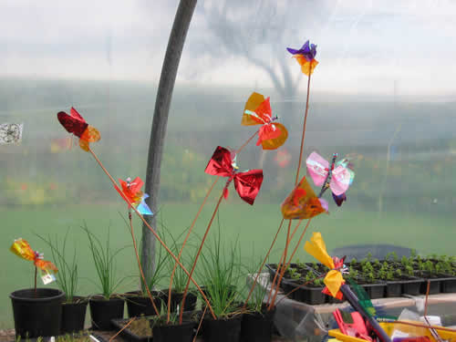
In June 2004 Borderland Voices achieved funding from Awards for All for the project 'Gardens of the Mind.'
We planned a series of participatory workshops held mainly at the John Hall Garden where we have our base, and at the Kniveden Garden on the outskirts of the town. Both gardens are run by the Social Enterprise Project in partnership with Rethink. Some workshops have also been held at a study centre in the beautiful Dove Valley.
The aims of the project intend to celebrate the richness and diversity of our garden heritage in the International year of the Garden 2004.
Running concurrently with our project, the Rural Education and Arts Project (REAP) ran a project entitled 'Enchanted Gardens' and Borderland Voices worked in partnership with them for two months culminating in a celebration at each of the two Leek gardens.
As part of the final celebration at the John Hall Garden in October, Borderland Voices designed and constructed a large table-top version of 'Snakes and Ladders' to be permanently sited in the garden, representing the 'Ups and Downs' of mental health.
Caterpillars were substituted for snakes and the counters were based on nature and included bird's nests, conkers, mushrooms, flowers and butterflies.
Below are some examples of the 'ups and downs' governed by the fall of the dice together with a photograph of the counters.
Ups 'Encouragement helps you grow tall' 'You find a friend' 'You feel loved' 'The sun comes out' 'Your tears bring calm like healing rain' 'Shared laughter lifts you sky high' 'Turn the music on, jump up and dance' 'Somebody praises you'
Downs 'You've done that wrong! Go back and start again!' 'Nobody loves you' 'You feel alone, down at the bottom of the world' 'The shadow of past failures brings you down' 'You feel powerless, bruised and broken' 'You lose your temper and hurt a friend' 'Criticism cuts like a sword' 'You didn't get the job-again!
